**IST772 Week 1 Breakout – RStudio Skills Check**

1. Install R and RStudio. The URLs for these are:  
   [https://cran.r-project.org](https://cran.r-project.org/)   
   [https://www.rstudio.com/products/rstudio/download/#download](https://www.rstudio.com/products/rstudio/download/" \l "download)

1. In R-Studio, open a new code file in the Code/Data Window (upper left). Using the #, type your name and a comment in the code window.

# Hendi Kushta

1. In the Content window (lower right), click the Packages tab to review downloaded packages. Install the modeest package. Library the modeest package into memory.

Install.packages(“modeest”)

library(modeest)

1. At the Console prompt (lower left pane), type **data()** and press return.

# it will show all the datasets that are already uploaded in R

data()

1. In the Code/Data Window (upper left), type **data()** and click Run.

# it will show all the datasets that are already uploaded in R

data()

1. In the Console window or in the Code/Data Window, type **View(trees).**

# It will show the data from trees dataset

View(trees)

1. In the Console window or in the Code/Data Window, type **summary(trees)**.

# Will find min, max, quartiles, median and mean.

summary(trees)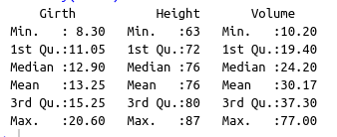

1. Generate a histogram by typing **hist(trees$Girth).** Repeat this for the other 2 variables in this data set.

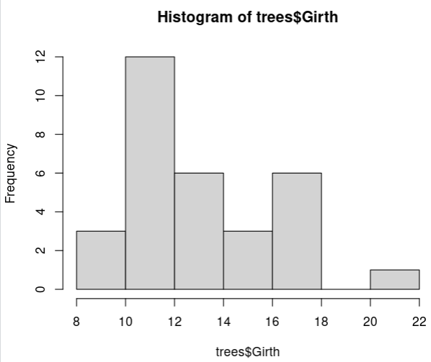

# It looks like bimodal distribution

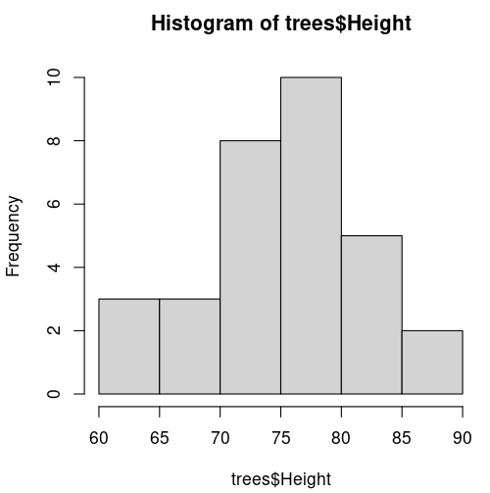

# it looks like symmetric distribution.

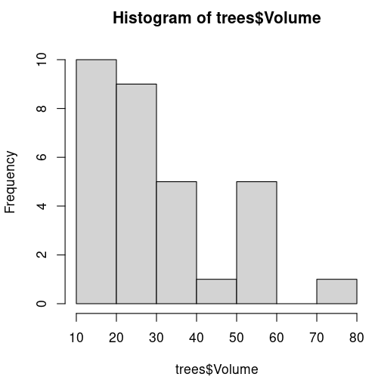

# It looks like right skewed distribution

1. Now generate a scatterplot by typing **plot(trees$Girth,trees$Height)**. Generate another scatterplot with the Girth and Volume variables.

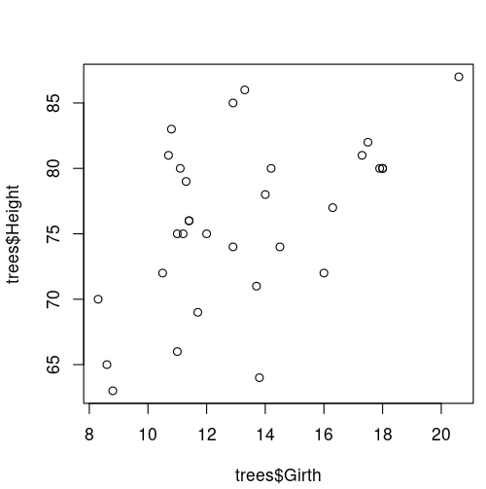

# There is no correlation between girth and height

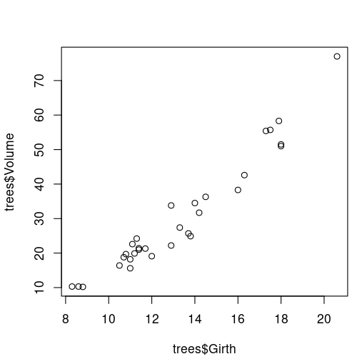

# There is a positive correlation between girth and volume of the tree.

Week 1 Breakout Discussion:

1. Comment on the shapes of the three histograms from #8.
2. Describe and compare what you see in the scatterplots from #9. Be specific and use variable names.

(Reply to at least 2 of your classmates in the Discussion.)